Chapter 1
Are you the sheep, shepherd or dog?
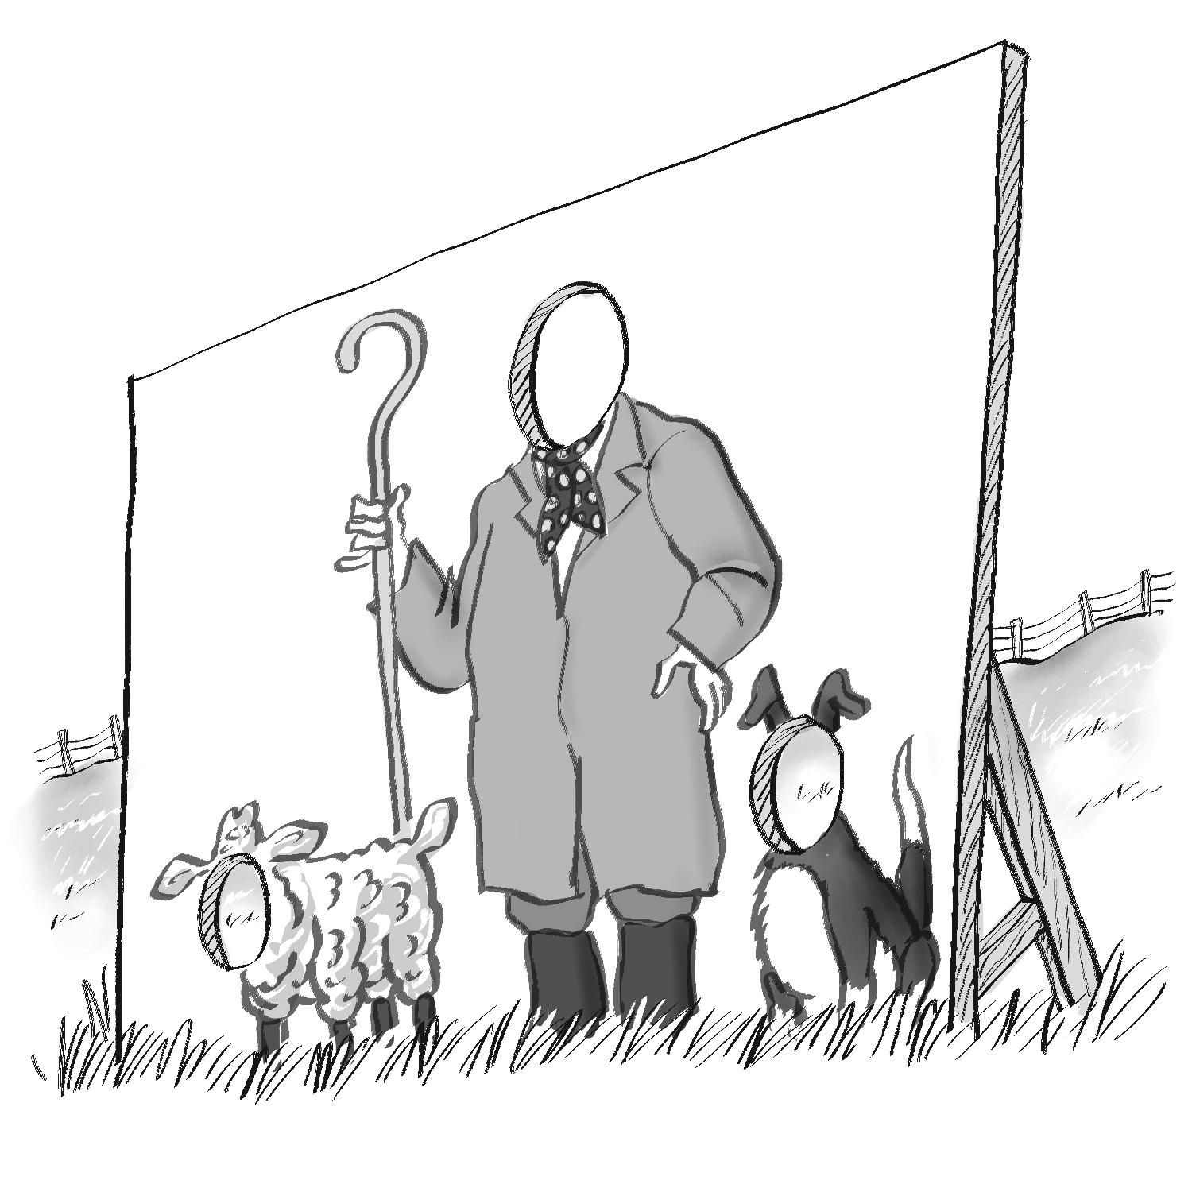
When faced with this question, and I’ve asked it hundreds of times over the last few years, it’s amazing the variety of responses people give.

Some people don’t want to answer the question; they feel possibly that it is a bit intrusive; it will tell me something about them that they would not want me to know. Asking this question out of the blue can be very revealing about how they deal with unexpected situations. On the other hand, most people find it an intriguing question, something they’ve never thought about before.

Most people will try to pick one of the three characters to fit their whole life. Most will think of the sheep at first glance, as the one that is lowest down the pecking order. It’s the animal that appears to be stupid and simple, and simply follows the others. Yet they have the impression of being light and fluffy, warm and cuddly, just being out there in the field simply grazing. A very simple life with very little to worry about. That sums up the sheep. So most people will dismiss the sheep: it’s not like them, as life could not be that simple, or they wouldn’t want it to be like that.

Their mind then turns to the shepherd. In their mind the shepherd is the one that makes all the decisions, is in control and is perceived to be at the top of the pecking order. This is more like it, at the top where they have control of what happens in their life. They are the ones making the decisions, setting the tasks and agendas for each day, the ones who look after everything. The shepherd is in their eyes the boss who sets the pace and direction for everybody else.

Thoughts then turn to the dog. They feel the dog is intelligent as well, but it is the one running around the sheep and doing all the work.. They get the sheep in the pen and the shepherd is there simply to close the gate. Often people will relate to this feeling; they are the ones doing all the work and somebody else just comes along and closes the gate to finish it off. Then the “shepherd” gets all the praise and glory, for doing a good job, appearing to care so much, although the dog has actually done 90% of the work to allow for the sheep to end up in the pen. All the dog gets is a small pat on the back, if it is lucky. A Bonio or some food at the end of the day and that is it, yet nothing would have happened without their work.

The look of horror on people’s faces when they think that they might be the dog! Oh my gosh, that is just like my life. Not just my job. Therefore I must be the dog. Oh gosh. That is the wrong answer isn’t it? That’s not right, I must do something about this. Why have I not noticed this until now?

This is a common response to the sheep shepherd or dog question. People often think that the shepherd is the “right” answer and any other is not being the best they can be.

For me, there is no right or wrong answer; there is simply a state of mind. The mindset of the sheep, the shepherd and the dog is very different.

https://youtu.be/eSi5qEeOG0w

The sheep’s mindset is predominantly one of little ambition. If food and water are available, the sheep really does not try to better itself at all. It will take and accept whatever life gives it.

The dog, on the other hand, is a lot more ambitious; it wants to do the best it can. Being top of the pack, the best it can be, having some control of what is around it, and having some effect on those around it. This is really important to the dog and it will work really hard to achieve that status. It also knows that working together as “the pack” will achieve so much more. The dogs are real team players and they know that they can be a powerful group. Any more than one dog can become a hunting pack with egos and personalities. Competition between dogs can be helpful at times, but can easily get out of control.

So what is the mindset of a good shepherd? Do they see themselves at the top of the tree? They obviously have responsibility for the animals under their care, the sheep as well as the dogs. Both animals are very different so need to be handled accordingly. The shepherd also has to manage his own mindset. The shepherd needs to make judgements every single day; what’s best to do on a day-to-day basis. Not only are they working with the animals, but also with Mother Nature, which can sometimes be a phenomenal force to fight against.

For the shepherd, the care of the sheep is really important. This is equally as important as having his faithful friend with him, his dog which is his right hand man. The shepherd has to set achievable tasks, not too high, as well as making life as easy as possible, for the dog, the sheep, as well as for himself. Shepherds often can’t work effectively in the rain (thank you Mother Nature). They will take a look at the sheep but they know that when it is raining it is a lot harder to work with the animals. The dogs are not quite so keen, the sheep are very wet and slippery to handle and if it is really heavy rain they will look for shelter themselves. I would say it is not a “win-win” situation.

When it is a hot sunny day shepherds will start early to make use of the cooler weather in the morning, or work late into the balmy evening. This is a “win-win” because the sheep are cooler, they’ll be rested; and the dogs will work better because they do not get so hot. Finally for the shepherd, getting the work done in the early morning when it is cooler means they can relax in the afternoon and evening, or if things have not gone so well finish off in the evening. When all three parties are in harmony life is wonderful. Getting that “win, win, win” situation is so important, not only in shepherding but in life in general.

